Project Design Phase-II
Data Flow Diagram & User Stories

Date | 03 January 2025
Team ID
Project Name
Maximum Marks | 4 Marks

Data Flow Diagrams:
A Data Flow Diagram (DFD) is a traditional visual representation of the information flows within a system. A neat and clear DFD can depict the right amount of the system requirement graphically. It shows how data enters and leaves the system, what changes the information, and where data is stored.
`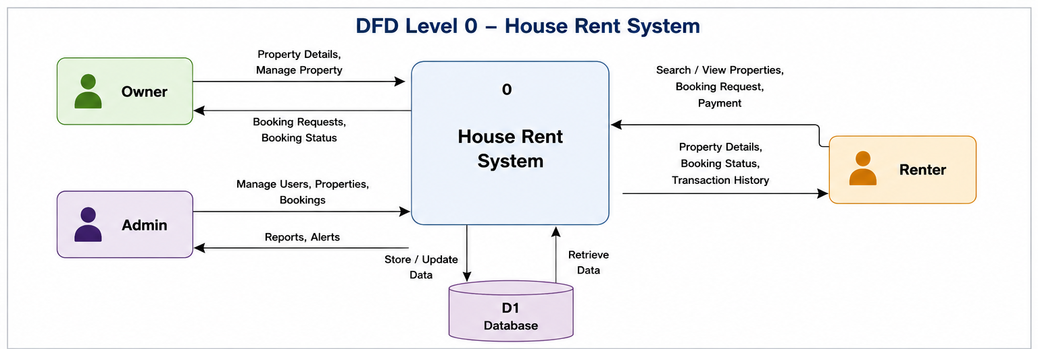
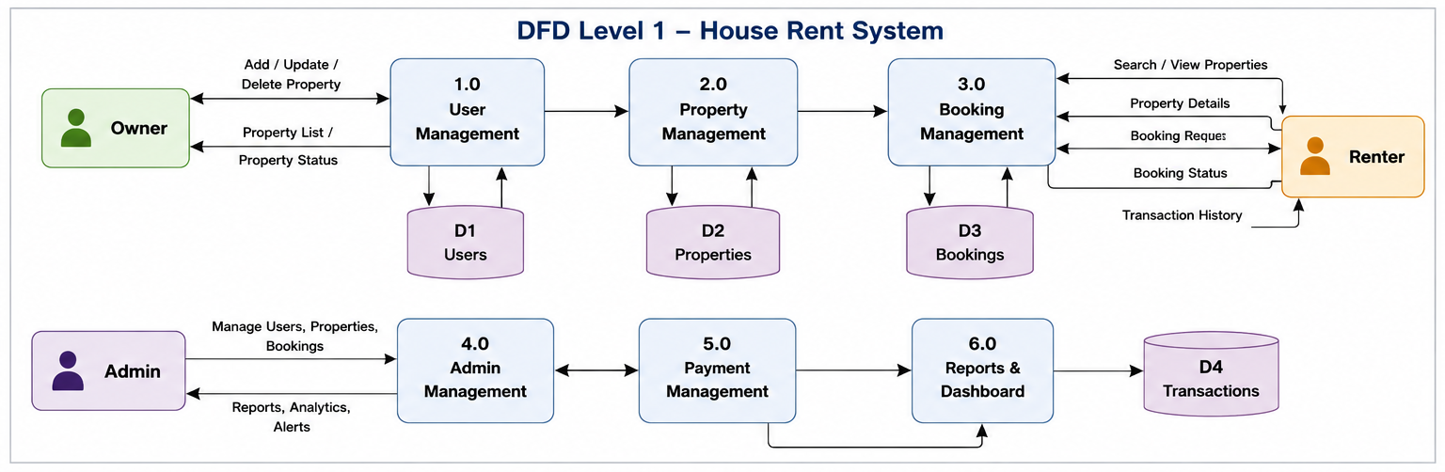

User Stories
Use the below template to list all the user stories for the product.
User Type | Functional Requirement (Epic) | User Story Number | User Story / Task | Acceptance criteria | Priority | Release
Renter (Web User) | Registration | USN-1 | As a renter, I can register for the application by entering my personal details. | I can successfully create my account and access the renter dashboard. | High | Sprint-1
 | Login | USN-2 | As a renter, I can log in using my registered email and password. | I can securely access my renter dashboard. | High | Sprint-1
 | Property Booking | USN-3 | As a renter, I can search rental properties using filters such as location, price, and property type. | Relevant properties are displayed based on my search criteria. | High | Sprint-2
 | Property Booking | USN-4 | As a renter, I can submit a booking request for my preferred property. | My booking request is successfully created. | High | Sprint-3
 | Property Booking | USN-5 | As a renter, I can view my booking | I can track all my previous bookings. | Medium | Sprint-3
Owner (Web User) | Property Management | USN-6 | As an owner, I can upload a new property with complete details and images. | The property is successfully added to the system. | High | Sprint-2
 | Property Management | USN-7 | As an owner, I can edit or delete my uploaded properties. | Property information is updated or removed successfully. | High | Sprint-2
 | Booking Management | USN-8 | As an owner, I can approve or reject booking requests. | Booking status is updated and visible to renters. | High | Sprint-3
Administrator | User Management | USN-9 | As an administrator, I can manage registered users. | User records can be viewed, updated, or removed. | High | Sprint-4
 | Property Management | USN-10 | As an administrator, I can manage all property listings. | Property records are maintained successfully. | High | Sprint-4
 | Booking Management | USN-11 | As an administrator, I can monitor and manage all bookings. | Booking records are managed successfully. | High | Sprint-4
All Users | Theme Settings | USN-12 | As a user, I can switch between Light Mode and Dark Mode. | The selected theme is applied successfully. | Low | Sprint-4

